PEOPLE COUNTER

Basic description:

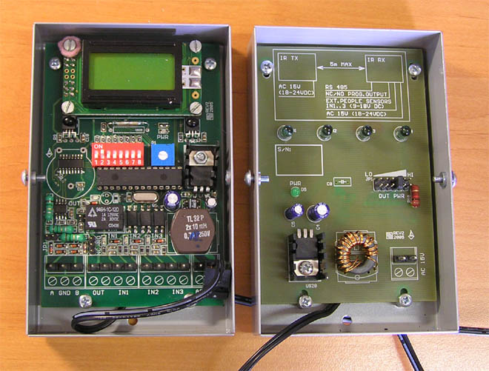

The counter consists of a transmitter and a receiver. Both are in metal boxes - size 125*80*30 mm. The receiver box contains a counter with a LCD display. The counter value can be erased using a strong magnet placed near the LCD display.
There are two sensors, 1 on the left side and the other on the right side of the Rx board.
Thus the counter can count people coming in and going out.
The accuracy of counting is not 100% because it is difficult to detect slow moving people the same way as fast moving. The signal delay is set to optimum which was found by hundreds of tests. It is normal when both numbers differ.
It is possible to connect the counter to a PC computer. To do this you must have a module that transforms R232 output to USB computer input. This module can be supplied extra with its own special power supply unit.
Two versions of the counter are available:
- simple without any PC transfer with just LCD display information
- PC compatible counter with the USB module

The people counter can be placed on an antenna with a special holder (optional) or in a stand (each box on its own) that can be mounted direct on the floor near an antenna or standalone.

